**Programming Challenges 4 May 23, 2019 - Due on or before Midnight May 23, 2019**

**Objective:** C++ string class

|  |
| --- |
| **Important instructions:**   * *All programs must include comments at the top of your program: your name, course name-section number (CS 575), program name and the program description in brief.* * *Copy and paste your program code and outputs in Part B of each program.* * *Once it is done, save and submit this word file via Canvas.* |

To receive full credit, your program must:

- Include simple, clear comments explaining your program logic

- Indent your code and line up your braces

- Give descriptive variable names

- Use name constants wherever possible. Name constant must declare with CAPITAL.

- You must submit two outputs.

The first input string to test must be the same as one of two given sample outputs.

The second input string to test must be your own make-up string.

1. **WordSeparator.cpp**

Write a program that accepts an input as a sentence in which all of the words are run together (no space), but the first character of each word is uppercase. Convert the sentence to a string in which the words are separated by spaces and only the first word starts with an uppercase letter.

Make sure to submit two outputs and use the following function prototype:

**string split(string);**

**Sample output 1:**

Enter a sentence: SheSellsSeaShellsOnTheSeaShore

The new sentence: She sells sea shells on the sea shore

**Sample output 2:**

Enter a sentence: TheButterSheBoughtWasABitBitterAndMadeHerBatterBitter

The new sentence: The butter she bought was a bit bitter and made her batter bitter

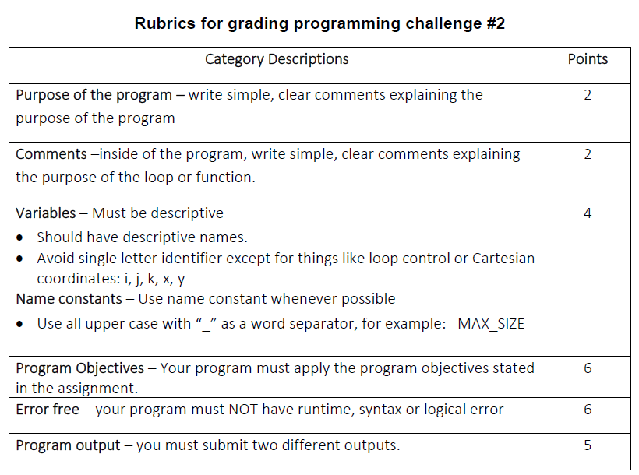

**Copy and paste your program (source) code and the outputs after this line**

**+++++++++++++++++++++++++++++++++++++++++++++++++**